ECPHRASTIC POETRY ACTIVITY
MATHEMATICS

Using the given stimulus material, create the following types of poetry:
- Free verse
- Acrostic
- Cinquain
- Haiku
- Limerick
Remember to complete the following steps:
- View a stimulus image and identify a mathematics-related concept it evokes.

- If required, write down the concept, definition, law, formula etc.

- Identify a suitable poetry type and write the poem.

STIMULUS IMAGE 1
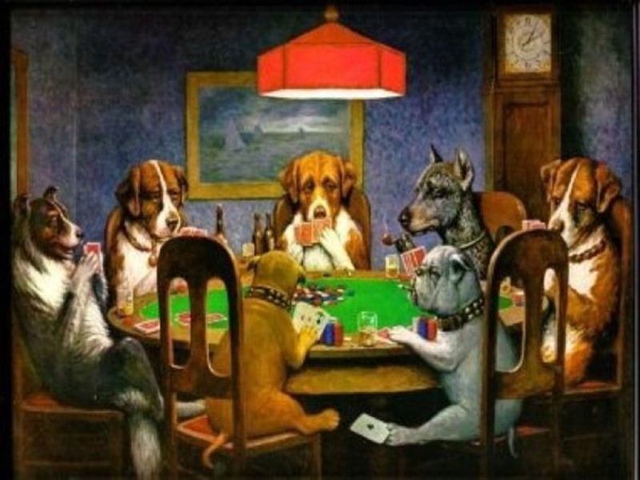
http://hphotos-snc1.fbcdn.net/hs248.snc1/9533_1251113879374_1275310067_753434_5348274_n.jpg

STIMULUS IMAGE 2
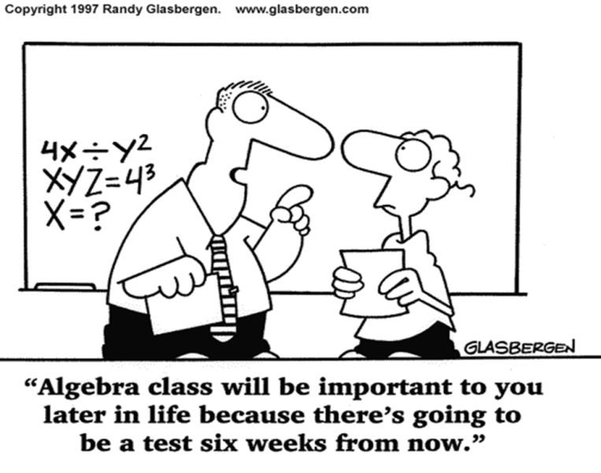
http://cfftjresources.wikispaces.com/file/view/algebra_cartoon.gif/194634384/algebra_cartoon.gif

STIMULUS IMAGE 3
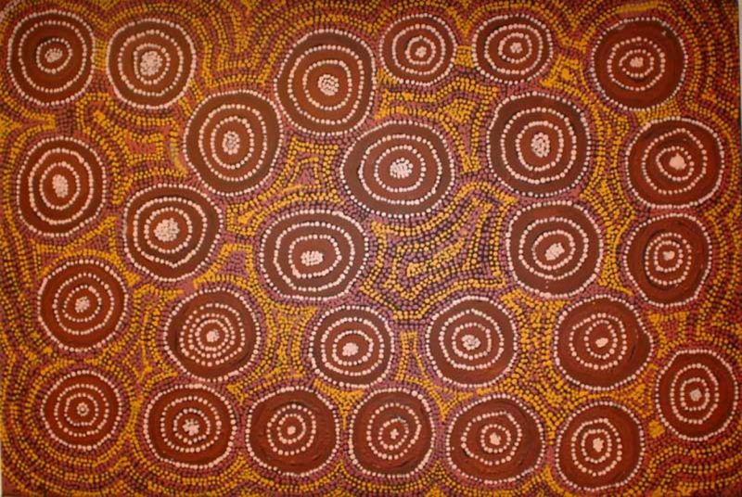
http://www.aboriginalartshop.com/aboriginal%20painting%20-%20dotting.jpg

STIMULUS IMAGE 4
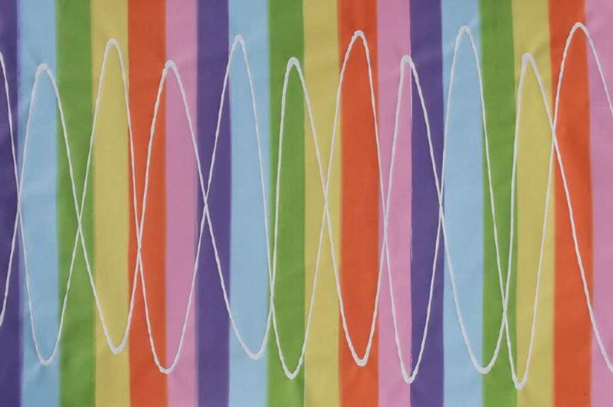
http://www.pendulumpainter.com/sinewavewholelores.jpg

STIMULUS IMAGE 5
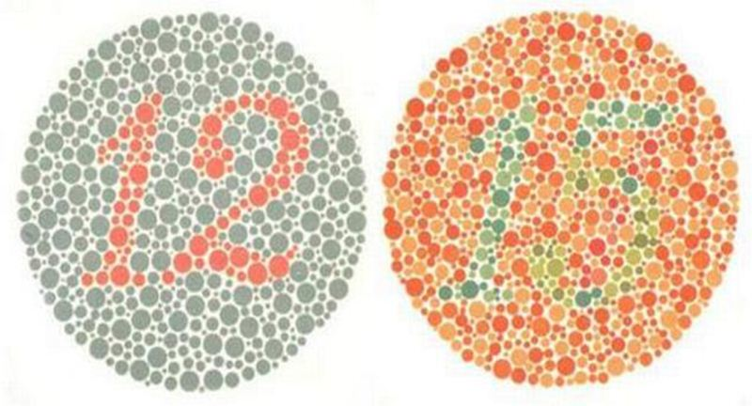
http://www.thehindu.com/multimedia/dynamic/00004/ColourBlindness_4671f.jpg

